A.V.KAVERI,
192512188.
EXPERIMENT – 9
9-A
PROGRAM CODE:
clc;
clear;
close all;
%% Objective 1: Ground Wave Propagation
Pt = 10; % Transmitted Power (kW)
d = 1:1:500; % Distance (km)
E_ground = (300*sqrt(Pt))./d;
%% Objective 2 : Sky Wave Propagation
h = 250; % Ionosphere Height (km)
theta = 60; % Angle of Incidence (degrees)
fc = 5; % Critical Frequency (MHz)
Skip_Distance = 2*h*tand(theta);
MUF = fc*sec(deg2rad(theta));
%% Objective 3 : Comparative Analysis
Sky_Range = Skip_Distance*ones(size(d));
%% Display Results
fprintf('\nGROUND WAVE AND SKY WAVE ANALYSIS\n');
fprintf('---------------------------------\n');
fprintf('Transmitted Power = %.2f kW\n',Pt);
fprintf('Ionospheric Height = %.2f km\n',h);
fprintf('Skip Distance = %.2f km\n',Skip_Distance);
fprintf('Maximum Usable Frequency (MUF) = %.2f MHz\n',MUF);
%% Plot Results
figure('Name',...
'Ground Wave and Sky Wave Propagation',...
'NumberTitle','off');
subplot(2,2,1)
plot(d,E_ground,'LineWidth',2)
grid on xlabel('Distance (km)')
ylabel('Field Strength (mV/m)')
title('Ground Wave Propagation')
subplot(2,2,2)
bar(MUF)
grid on
title('Maximum Usable Frequency')
ylabel('Frequency (MHz)')
set(gca,'XTickLabel',{'MUF'})
subplot(2,2,3)
bar(Skip_Distance)
grid on
title('Skip Distance')
ylabel('Distance (km)')
set(gca,'XTickLabel',{'Sky Wave'})
subplot(2,2,4)
plot(d,E)

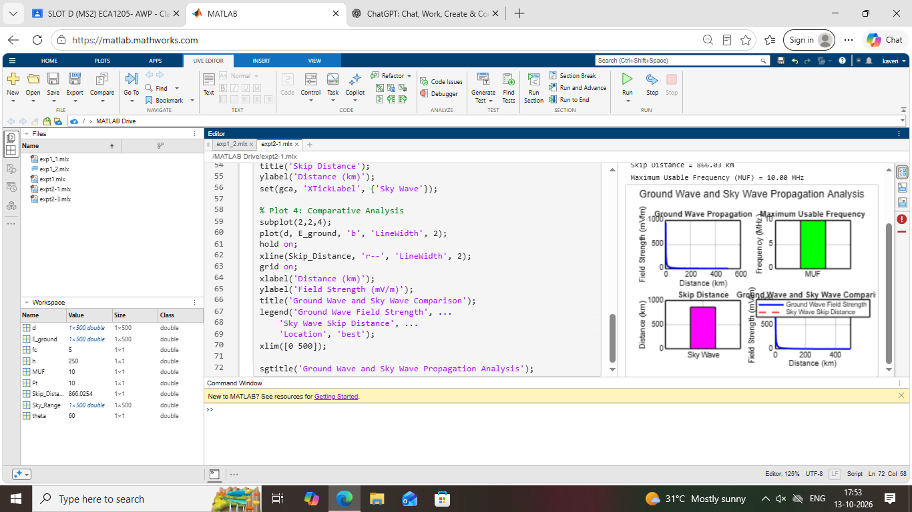

9-B
PROGRAM CODE:
clc;
clear;
close all;
%% Objective 1 : Space Wave Propagation
f = 900; % Frequency (MHz)
Pt = 30; % Transmit Power (dBm)
d = 1:1:100; % Distance (km)
FSPL = 32.44 + 20*log10(f) + 20*log10(d);
Pr = Pt - FSPL;
%% Objective 2 : LOS and Radio Horizon
ht = 50; % Transmitter Height (m)
hr = 25; % Receiver Height (m)
d_LOS = 4.12*(sqrt(ht)+sqrt(hr));
%% Objective 3 : Link Budget Analysis
Gt = 10; % Tx Gain (dB)
Gr = 8; % Rx Gain (dB)
Pr_link = Pt + Gt + Gr - FSPL;
%% Display Results
fprintf('\nSPACE WAVE PROPAGATION ANALYSIS\n');
fprintf('---------------------------------\n');
fprintf('Operating Frequency = %.0f MHz\n',f); fprintf('LOS Distance = %.2f km\n',d_LOS);
fprintf('Received Power at 10 km = %.2f dBm\n',Pr(10));
%% Plot Results
figure('Name',...
'Space Wave Propagation Characteristics',...
'NumberTitle','off');
subplot(2,2,1)
plot(d,FSPL,'LineWidth',2)
grid on
xlabel('Distance (km)')
ylabel('FSPL (dB)')
title('Free Space Path Loss')
subplot(2,2,2)
plot(d,Pr,'LineWidth',2)
grid on
xlabel('Distance (km)')
ylabel('Received Power (dBm)')
title('Received Power vs Distance')
subplot(2,2,3)
bar(d_LOS)
grid on
title('LOS Communication Range')
ylabel('Distance (km)')
set(gca,'XTickLabel',{'LOS Range'})
subplot(2,2,4)
plot(d,Pr_link,'LineWidth',2)
grid on
xlabel('Distance (km)')
ylabel('Power (dBm)')
title('Link Budget Analysis')



